COAL LAB #5
Exercise#1
PROGRAM 1:
org 100h
MOV AL, 4
INC AL
RET
OUTPUT:
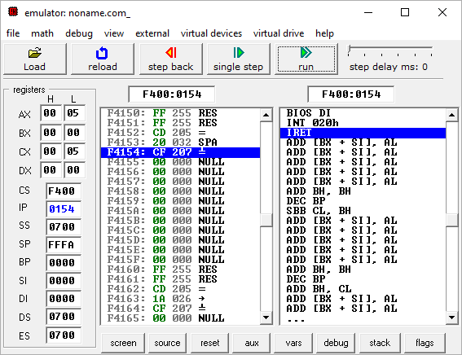

PROGRAM 2:
org 100h
MOV AL, 255 ; AL = 0FFh (255 or -1)
DEC AL ; AL = 0FEh (254 or -2)
RET
OUTPUT:
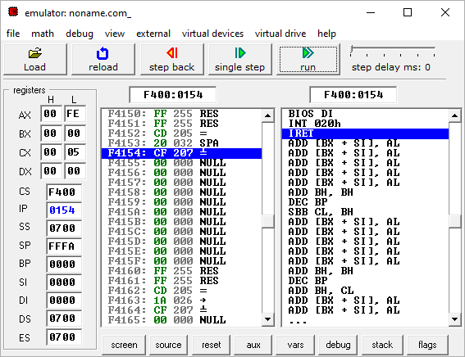

PROGRAM 3:
org 100h
MOV AL,5 ; AL = 05h
NEG AL ; AL = 0FBh (-5)
OUTPUT:
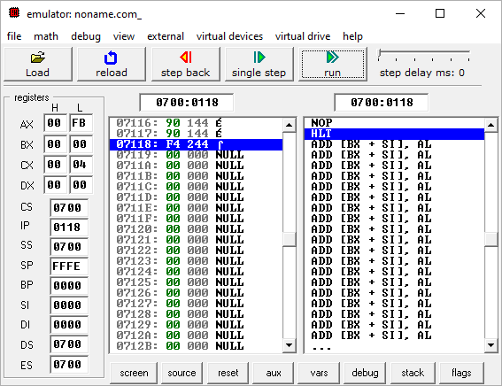

PROGRAM 4:
Org 100h
MOV AL,5 ;AL=5
ADD AL,-3 ;AL=2
RET
OUTPUT:
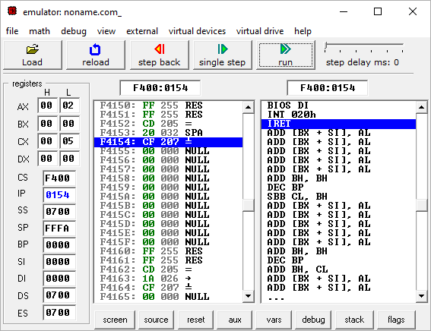

PROGRAM 5:
org 100h
MOV AL, 5
SUB AL,1 ;AL=4
RET
OUTPUT:
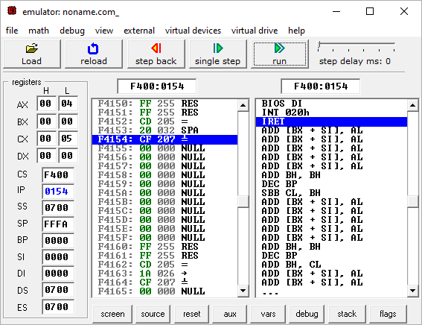

PROGRAM 6:
Org 100h
MOV AL, 200 ; AL = 0C8h
MOV BL, 4
MUL BL ; AX = 0320h (800)
RET
OUTPUT:
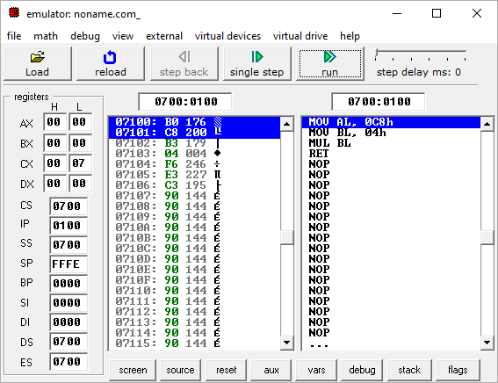

Exercise #2
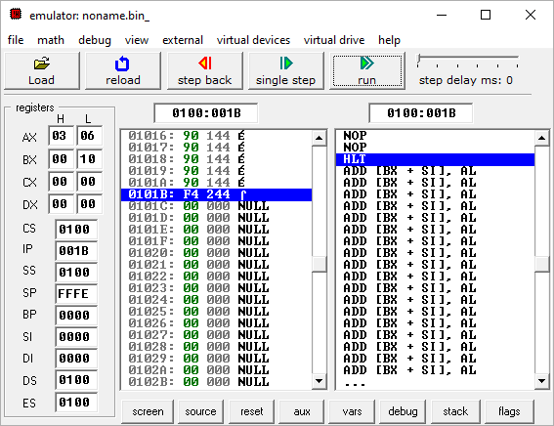

AH | AL
03 | 06

Exercise #3
CODE:
org 100h
mov ax, 5
mov bx, 3
mul bx
mov var1, ax
ret
var1 dw 0
OUTPUT:
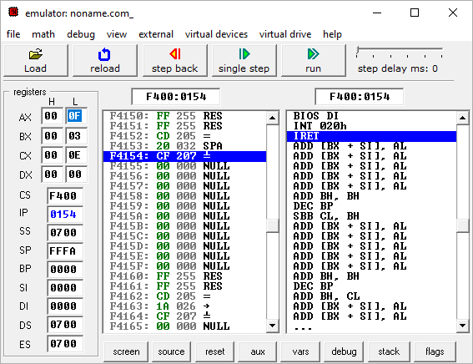

Exercise #4
CODE:
org 100h
mov ax, 276
mov bl, 10
div bl
mov var1, ax
ret
var1 dw 0
OUTPUT:
